Alton on the Biden Debate Debacle
Are you ready to "circle back after the debate"? I am with my "circle back comments," of which I apologize for its tardiness. Still, have you gotten your fill of "post Biden-Trump debate" comments? I have, as I think you also have. But since I have a few more "post Biden-Trump debate" comments to make, I like to remind you that, as the old JELL-O ads once said, "there's always room for JELL-O," there's also always room for more of everything else!

Before I get to my comments, I want to add one more comment related to our discussion about online political betting. Namely, a comedian recently joked that he's all in favor of transgender males competing in women's sports, as long as he can bet on the transgender male athlete. ("Good joke sound effect," follows)
 | Ba dum tss  www.youtube.com
Anyhow, as you may know, Biden didn't do well during the debate. (If anyone somehow missed the debate, "Liberal Hivemind" provides some highlights or "lowlights.") Indeed, he did so badly that criticisms and recriminations quickly surfaced, and more than a few "elite" Democrats probably engaged in Marxist-Maoist "self-criticism." Some of my favorites of these criticisms include, MSNBC changes its tune on Joe Biden following ‘trainwreck’ presidential debate, whose YouTube was hosted by "Sky News Australia's" Rita Panahi who said, "it’s hard to deny what came out of the 'trainwreck' presidential debate between Joe Biden and Donald Trump."
MSNBC changes its tune on Joe Biden following ‘trainwreck’ presidential debate
Sky News host Rita Panahi says it’s hard to deny what came out of the “trainwreck” presidential debate between Joe Biden and Donald Trump. “The decline in recent years is undeniable ... but the overwhelming majority of the media has asked you to not believe your lying eyes and ears and trust the narrative that Joe is fine,” she said ...
www.youtube.com
NBC even weighed in with its report, 'Babbling' and 'hoarse': Biden's debate performance sends Democrats into a panic
Biden's debate performance sends Democrats into a panic
The president often had a weak, raspy voice during his first debate against Trump, in what Democrats had hoped would be a turning point in the race.
www.nbcnews.com
The consequent, almost "knee jerk," calls for Biden's replacement came from many quarters, including this one from Sky News Australia (what's up with those Australians meddling in US politics?): Calls for Joe Biden to step aside as Democratic candidate
Calls for Joe Biden to step aside as Democratic candidate
There have been more calls for US President Joe Biden to step aside as the Democratic candidate in this year’s presidential election. This comes after his poor performance in CNN’s presidential debate with former US President Donald Trump. The editorial board of the New York Times is calling on Mr Biden to leave the presidential race saying ...
www.youtube.com
Interestingly, as names are suggested to replace Biden (Kamala remains, thank you, because she is the Democrats' current DEI VP and she will be their 2024 DEI Candidate for VP; to remove her would be, you know), Scott Morefield at Townhall.com tells us that If you’re Calling for Biden’s Removal, You’re Helping Democrats
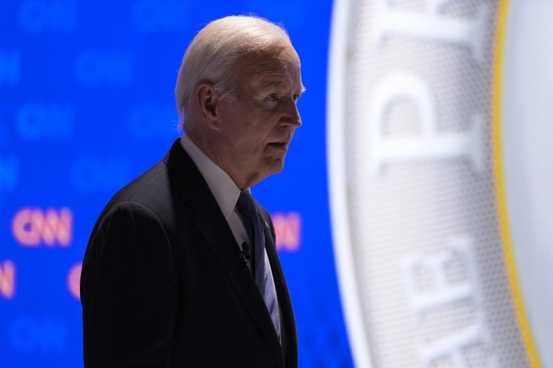 | If You’re Calling for Biden’s Removal, You’re Helping Democrats  townhall.com
Scott's most salient points are:

As we’ve seen from the past three years, it doesn’t make much of a difference who is at the helm. The job as described is actually too complicated for any one person, no matter how smart and quick-thinking that person may be. It does, however, matter who surrounds the president, who runs the agencies, and who pulls the strings behind the scenes. And if Weekend at Bernie’s gets replaced, the same people will be doing all those things, except they’ll be emboldened by the prospect of getting to repeat it all for yet another presidential term.

Our only goal between now and Election day should be to get Donald Trump elected President of the United States. Consequently, the only question we should be asking regarding Biden’s removal is this: Would Biden’s removal at the top of the ticket help Donald Trump get elected President of the United States? It’s that simple, and the answer is simple as well. No, removing the weakest candidate Democrats have run since Walter Mondale does NOT help Trump get elected. In fact, replacing Biden with almost anyone would almost certainly HURT Trump’s chances, which is why so many Democrats are in panic mode to make this happen.

Before the debate started last week I tweeted this: “Should Trump have waited to debate Biden until both are formally nominated? If this is a massacre and ends in Biden being replaced, it would be one of the biggest political miscalculations in history.”
Given how things have played out so far, it seems that agreeing to a debate this soon was a mistake, albeit an honest one. We shouldn’t want Biden—Trump’s best shot at winning—replaced on the ticket, and we shouldn’t help Democrats right their ship by lifting a finger to make that happen.
Scott Morefield, as you'll agree, made an excellent point, though he's not buoyantly confident of an easy win for Trump should he run against a Biden replacement. Still, Scott Morefield, Trump and all those who want to be on the right side of history may want to rejoice when they learn of The Hill's report: Biden campaign official: He’s not dropping out
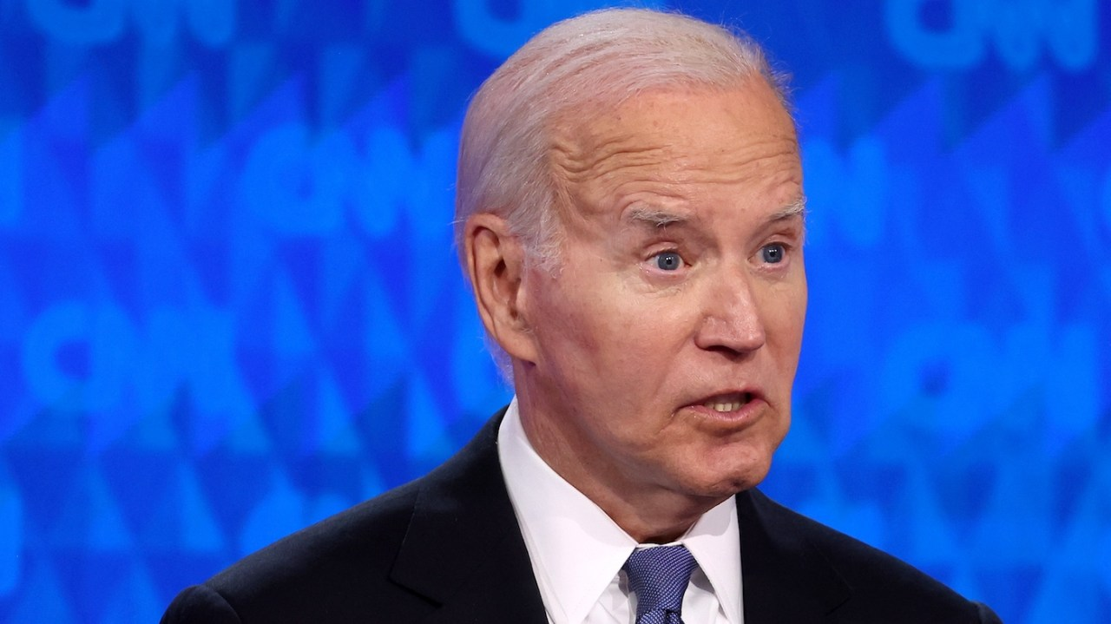 | Biden campaign official: He’s not dropping out  President Biden is “not dropping out” of the 2024 race, a campaign official said following a shaky debate performance late Thursday that spurred talk among some Democrats of whether he …  thehill.com
(I understand that when reporters and pundits asked Biden whether he would reconsider dropping out "for the good of the nation," he angrily replied, "You should drop dead!")

And rest assure, White House loyal guard dog, KJP, steadfastly maintains her master's mental agility and that he is soundly fit for Presidential duty.

Anyhow, I frankly found the debate embarrassing. It was like a bad joke. Here was a feeble, doddering old man, who slurred his words, that is, when you can even hear him, as he often spoke so softly and hoarsely. Even so, what he said was often incoherent and made no sense. He looked terrible, with his puffy face and pallid skin, which was probably the result of the "Super Soldier Serum that turned Steve Rogers into Captain America" that USA Today columnist Rex Huppke, in his opinion piece I previously mentioned, suggested could be pumped into Biden. And it didn't help Biden, when he often looked bewildered with his eyes wide open, and mouth agape, as we wait to see spittle drip.

What happened to the Biden from a few short years ago who was feisty and lively as he battled Bernie Sanders, Elizabeth Warren Battle Over Medicare for All?
Joe Biden, Bernie Sanders, Elizabeth Warren Battle Over Medicare for All | NowThis
Joe Biden, Bernie Sanders, and Elizabeth Warren battled it out over Medicare for All vs. the public option — here’s what they had to say about the ‘damn bill.' » Subscribe to NowThis: http://go.nowth.is/News_Subscribe » Sign up for our newsletter KnowThis to get the biggest stories of the day delivered straight to your inbox: https://go ...
www.youtube.com
The Biden during Thursday's debate is now an empty shell of that man. And yes, arguably Trump had won the debate. But the way Trump lord it over the doddering President of the most powerful nation in the free world, was absolutely shameful. Indeed, Trump should be arrested for elder abuse!

Still, during Biden's few-in-number "lucid" moments, did anyone catch him say that he will continue to support Zelensky and Ukraine with money and weapons? More importantly, he said it's because he knows Putin is a killer, who will stop at nothing to take over Ukraine. Biden believes he must urgently stop Putin else Hungary and Poland will be his next targets for takeover after he takes over Ukraine. In other words, Biden believes Hungary and Poland and other countries after them will "fall like dominoes" unless he stops Putin.

Gee, wasn't that a key reason given for the US presence in Vietnam: to protect South Vietnam from falling to the Communists, lest nearby countries will "fall like dominoes," as the Communists invade and take over those countries? We certainly "saved" South Vietnam at the cost of 58,279 American military lives, didn't we? (Was it "worth it"?)

And who remembers Biden calling Trump a "whiner" for not accepting his 2020 election defeat? I do. Biden even "rubbed it in" when he reminded Trump that not a single court would hear any of his many claims that the election was "stolen." I was hoping to hear Biden repeat his claim that he received over 81 million votes, the "most ever cast for a President," but he didn't.

I tried to find earlier videos of Biden making this claim, but Google seems to have hidden them from its searches. If anyone can find them, please send them to me. Still, I can readily find Guinness World Records' recognition of Biden receiving the most votes cast for a US presidential candidate.
Most votes cast for a US presidential candidate
www.guinnessworldrecords.com
A "placard" said:
The most votes cast for a US presidential candidate is 81,281,502, received by Joe Biden (USA) in the 2020 US presidential election held on 3 November 2020.
Biden’s rival, incumbent Republican president Donald Trump, also bettered the previous highest tally with 74,222,593 votes. Figures were provided by the non-partisan Cook Political Report.
Fine. So together, Biden and Trump received an official, "actual" total vote count of 155,504, 095 votes cast during the 3 November 2020 election. Truly, our democracy works!
But there's a slight "anomaly" that I wonder whether Joe Biden, or Trump or anyone else, for that matter, can explain. It stems from an item that appeared in the Federal Register, which is dubbed "The Daily Journal of the United States Government," and it's published by the National Archives and Records Administration (NARA), an independent Federal agency. This is the same agency that's at the heart of the "Missing Classified Document Gate" controversy. NARA, of course, is having Trump prosecuted for mishandling Classified Documents, but it has allowed Biden to go Scott free for the same "crime."
Still, the anomaly specifically stems from the Federal Register's item, “Estimates of the Voting Age Population for 2020,” which reports the voting age (18 and over) population estimates, as of July 1, 2020, for each State and the District of Columbia as totaling 256,662,010.
Estimates of the Voting Age Population for 2020
This notice announces the voting age population estimates as of July 1, 2020, for each state and the District of Columbia. We are providing this notice in accordance with the 1976 amendment to the Federal Election Campaign Act. It is important to note that these estimates are based on the 2010...
www.federalregister.gov
To see this anomaly, we must first suppose that everyone in this population can legally vote in 2020. But to vote, they must register with their local election boards. Let's further suppose that 60% of this population had registered. Since not every registered voter will vote, how many will actually vote? According to The Washington Post, “… 66.3%, which is a share of the voting-eligible population," i.e., registered voters.
Next, let's do the math: 60% of 256,662,010 = 153,997,206 total registered voters; with 66.3% voting = 102,100,148 total votes cast. “Houston, we have a problem.” It doesn’t seem to get better. The math for: 70% registered voters with 66.3% voting = 119,116,839 total votes cast; 80% registered voters with 66.3% voting = 136,133,530 total votes cast; and 90% registered voters with 66.3% voting = 153,150,221 total votes cast — “Close, but no cigars.”

So, it seems the Federal Register's "Estimates of the Voting Age Population for 2020,” can't seem to provide the actual total votes cast of 155,504, 095 during the 3 November 2020 election. Truly, an anomaly.

Joe Biden, who Guiness proudly declares, received 81,281,502 votes in the 2020 presidential election, "the most votes ever received by a US Presidential candidate," can he explain this anomaly? Can Donald Trump, or anyone from NARA, or anyone else for that matter, explain this anomaly? (How about you, Helene? Can you explain this anomaly?) This anomaly is truly a mysterious phenomenon, that's up there with UFOs and how it's humanly possible (even by the standards of ordinary corrupt politicians) to amass a national debt of over 35 Trillion dollars, which certainly and absolutely dwarfs the total 155,504, 095 actual votes Biden and Trump received in the 2020 election.

While we wait for an answer, Helene, I want to turn to the "wonderfully wacky" Ann Coulter, who you previously referred to as "my gal." Ann Coulter has, surprise, surprise, a "Podcast" on the Ricochet Audio Network, Unsafe with Ann Coulter.
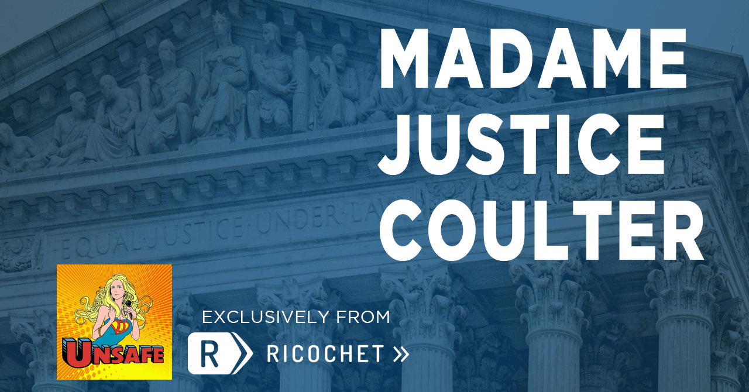 | What You Need to Know - Week of July 1, 2024  The Supreme Court term has finally come to end with the issuance of the last opinions – including the most consequential: Trump v United States. Ann reviews that plus three opinions issued late last…  ricochet.com
For the Week of July 1, 2024, Ann tells us "There’s so much news out of the Supreme Court in the past week that the fact that Democrats put a vegetable on stage to debate Trump is only my fifth topic.
- Trump v United States
- “Chevron” sounds like a boring case, but it will have a huge impact on your life.
- J6 “Obstruction”
- Can cities ban homeless people from sleeping, pooping and camping on sidewalks and public parks? What if it’s Joe Biden?
- The Presidential Debate that you will never forget.
Lest I forget, Ann Coulter asked me to refer my friends and colleagues to join her podcast:

It seems she offers "Rewards and Progress" for the number of my "referrals" who joins her podcast. I'm uncertain how she will dish out those "Rewards and Progress," but if you like her Podcast, do join and sign up for her emails at the least (just copy the link), even if you don't want to pay to join.

And one more thing, since Ann Coulter is a "nativist," here's a YouTube item that should interest her, and many of you who are concerned with illegal immigration: "Top 10 Countries Wrecked by Migrants: The Unseen Consequences."
Top 10 Countries Wrecked by Migrants: The Unseen Consequences:
Welcome to our channel, Mars Sunset Media! In this eye-opening video, we explore the top 10 countries that have faced significant challenges due to large-scale immigration. While immigration can bring numerous benefits, such as cultural diversity and economic growth, it can also create complex problems when not managed properly. From social ...
www.youtube.com
Bet you can't name the #1 country that's "wrecked by migrants."

With that challenge, I end my "circle back comments." I hope you enjoy reading them, and I thank you and everyone for reading them.

If you have your own "circle back comments" ready, I'd love to read them. (Or, everyone, I invite you to submit any comments or questions about my "circle back comments." I'd love to read them and share them with everyone.😁

